3x3 Observations: December 2009
Electives – 8 Classes

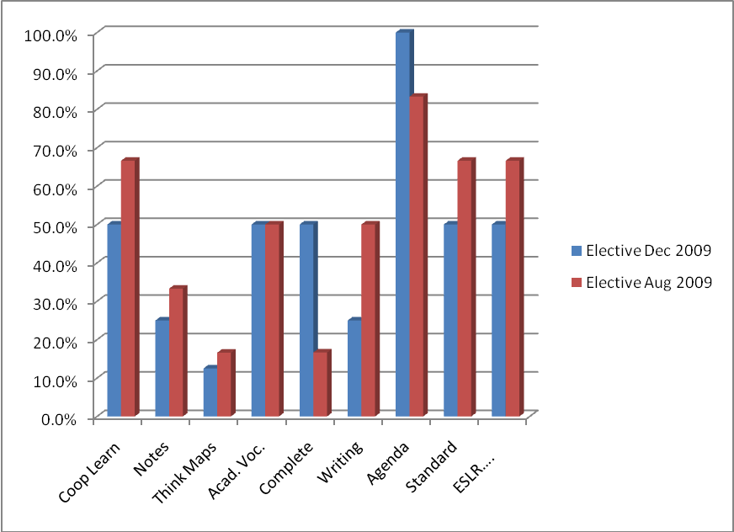

ELECTIVE | Coop Learn | Notes | Think Maps | Acad. Voc. | Complete | Writing | Agenda | Standard | ESLR….
Dec 09 | 50% | 25% | 13% | 50% | 50% | 25% | 100% | 50% | 50%
Aug 09 | 67% | 33% | 17% | 50% | 17% | 50% | 83% | 67% | 67%

